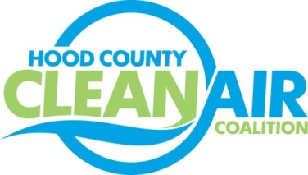
Meeting: Wednesday, August 1, 2018
Neely House
304 E. Rucker St. Granbury, Texas 76048
8:30-10:00 a.m.

Agenda

- Call Meeting to Order
- EPA Updates – Randy Pitre, EPA
- Local Updates – Michelle McKenzie
  - Review of July Meeting Summary
  - Review of Projects
    - Monthly Budget Review for June
    - Closeout of Rider 7
    - Status of Projects
  - Reports
    - July Ozone Update
    - Healthy Children Coalition for Parker County
    - Air North Texas
- Regional Updates – Michelle McKenzie
  - New Website for NCTCOG: www.nctcog.org
  - EPA Designates Bexar County as Nonattainment
  - DFW Clean Cities Bi-Annual Meeting and Fleet Awards on August 21: https://www.dfwcleancities.org/dfw-clean-cities-meetings
  - Funding Opportunities: www.nctcog.org/aqfunding
Fleets, individuals, businesses, etc. can take advantage of the State incentive of $2500 for EVs or $5000 for propane/natural gas. Several propane and natural gas truck conversions are now approved for funding. Details are at https://www.tceq.texas.gov/airquality/terp/ld.html
- Other Discussion
- Adjourn

